|  |
| --- |
| **Vendor Master Data** |

Table of Contents

1. Introduction 3

1.1 Purpose 3

1.2 Roles 3

1.3 References 3

2. Standard Data 4

2.1 Standard data required for vendor setup 4

2.2 Components wise required data 5

3. Vendor Master Request Details 9

4. Vendor Change Request Details 13

4.1 Supporting documents required for Vendor Change request 15

4.2 Supporting documents not required for below mentioned changes 16

5. Vendor Block and Delete Request 17

5.1 Vendor blocks for Payment and required supporting document. 17

5.2 Vendor block for postings. 17

5.3 Vendor Delete Requests. 18

6. Types of Forms Required as a Supporting Document 18

7. Bottlers Approvers 20

8. New Bank Validation Process 20

8.1 Bank details change request form. 20

8.2 Flow chart of bank details updating 21

9. Process to Validate Forms 23

10. Standard Messgaes To Use in Response To Bottlers 23

11. Steps to Perform before Processing Vendor Requests 24

12. Default Payment Terms 25

13. List of Documents which will be processed in Vendor Master Data Manag 27

14. How to setup Vendor Master 28

15. Extending Vendor data to Company Code level 51

15.1 Extending Vendor Data to Purchasing Org 52

16. Bank Changes 54

17

# Standard Data

* 1. ***Standard data required for Vendor Setup.***

1. *Below mentioned account groups needs to be used while creating vendor.*

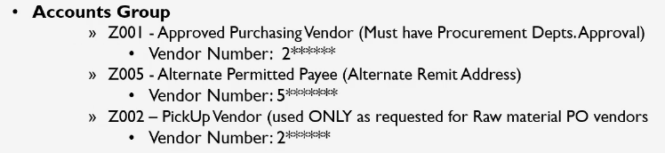

1. *Payment methods, which will be used.*

* *ACH; Checks*

1. *Four components of the Vendor Master Data*

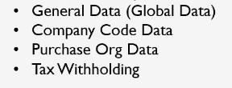

1. *T-Codes to be used for Vendor creation and maintenance*

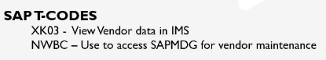

* 1. ***Component wise required Data***
* ***General Data (Global Data)*** *– The data is shared across the bottlers and business unit. The below highlighted data will be used after instructions from BSNA.*

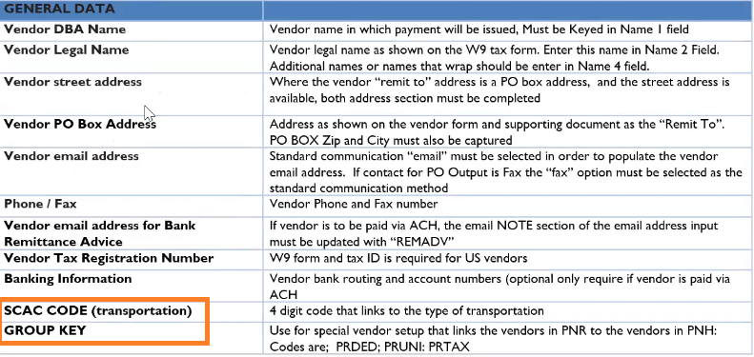

* *General fields need to be confirmed by all bottlers.*
* *The change request (CR) will be routed to all bottlers for which this vendor is extended to for approval.*
* *The Manager reviews the CR and supporting documents based on master data guidelines and can reject the CR if there are no sufficient documents provided.*
* ***Company Code Data*** *– The data is considered as local data because it is specific by bottler.*

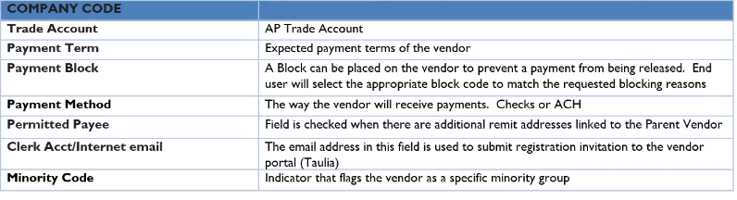

* ***Purchase Organization Data (PORG)*** *– The data enables the buying process via Purchase Order for both Indirect and direct purchases. The PORG is needed to outline agreement creation for Direct Vendors and the linking to SRM for indirect purchases.*
* *GRIV flag is imported redirect EDI invoices to IMS for AP team to work upon*
* *GRIV is flagged in case of PO vendors only.*



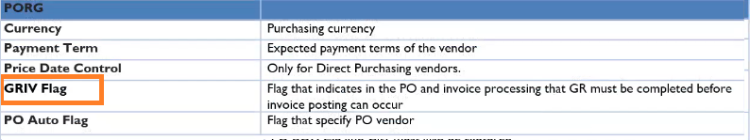

* ***Tax Withholding*** *– This data is relating to W8 and W9 tax information.*
* *Information related to W9 Form. These forms will be required for domestic based vendors*

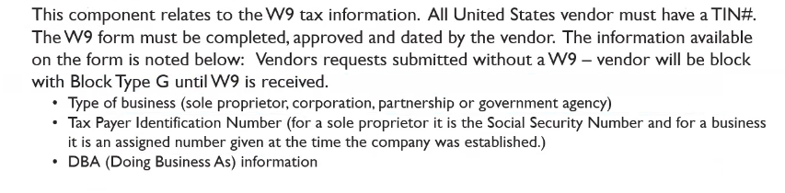

* *Information related to W8 Form; These forms will be required for foreign based vendors*

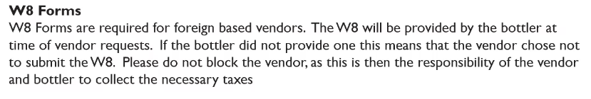

*Canadian vendors do not required w8 or w9 form attached with the form however; they will have a Canadian form attached with the invoices or vendor request.*

* *The below types of Vendors does not require 1099 Form reporting.*

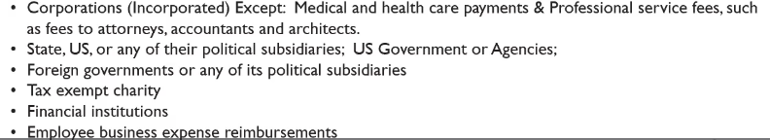

***W-9 Form Management***

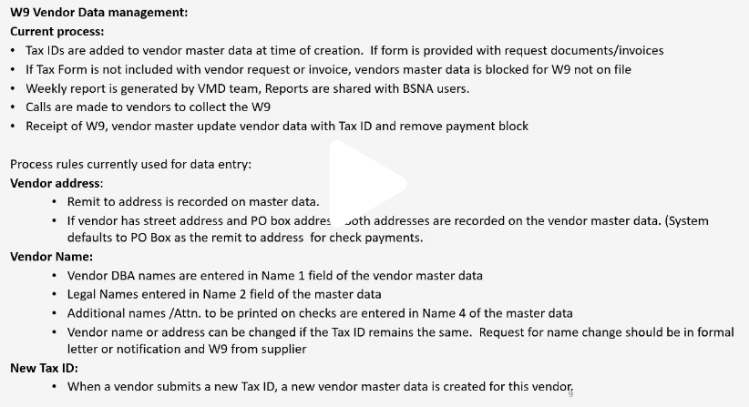

*Supporting documentation should be attached in MDG.*

***D. NON SAP PO based Suppliers – only permitted ( permitted address only )***

* *All creations and changes for vendor master are entered via SAPMDG and will trigger a validation step prior posting to SAP (PNR).*
* *The validation is performed by AP/Supervisor to ensure all the information/supporting are provided and then the request is approved or rejected.*
* *Approval will move the request to SAP; Rejection will move the request to VMD clerk for correction.*

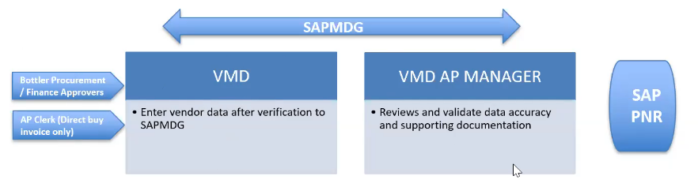

***TAT for Local vendors ( shared across with other all bottlers) and Global Vendors***

***Local vendor for company code level changes****.*

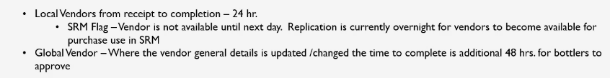

* ***Forms required for new Vendor Creation***

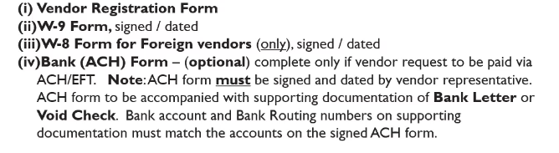

# *Vendor Change Requests detail*

* ***Shared Vendors changes/updates request process***

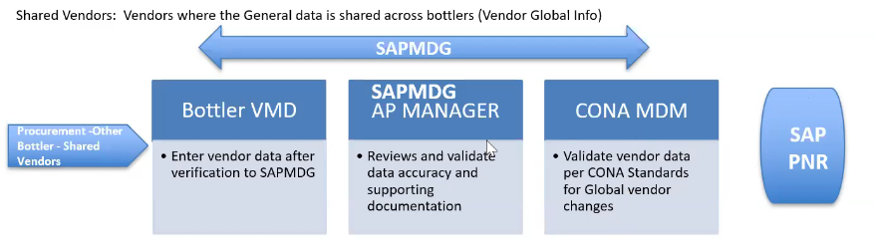

* ***In case of updates in Company code data the first two steps shown above will only be performed.***
* ***If there are updates in Global data, all the above steps will be performed.***

***Below points needs to be refer while updating***

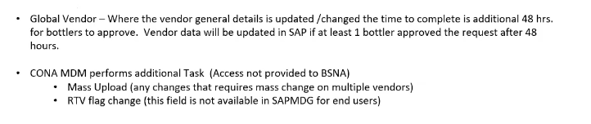

* 1. ***Supporting documents required for Vendor Change request***
* *The completed form must be reviewed by the bottler authorized individuals.*
* *Request, which are not authorized, will be returned for resubmission.*

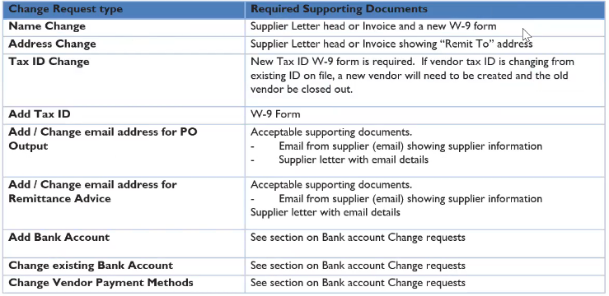

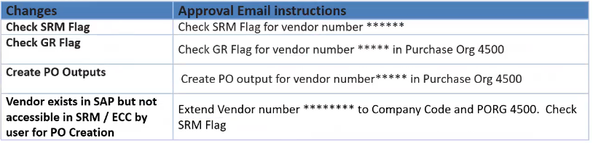

1. ***Vendor Block and Delete Request***

* *Vendor may be blocked for transaction posting or payments by Vendor master team.*
  1. ***Vendor blocks for Payment and required supporting doc.***

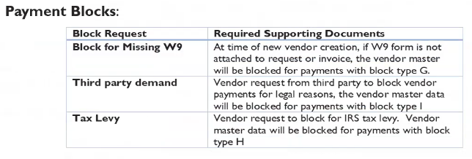

* 1. ***Vendor block for postings***

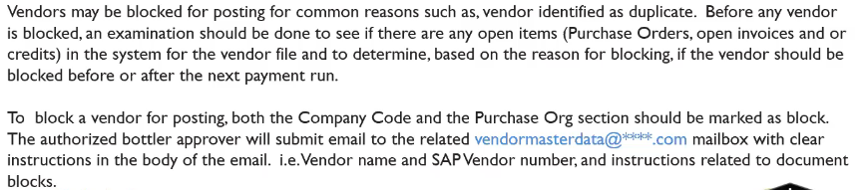

* 1. ***Vendor Delete Requests***

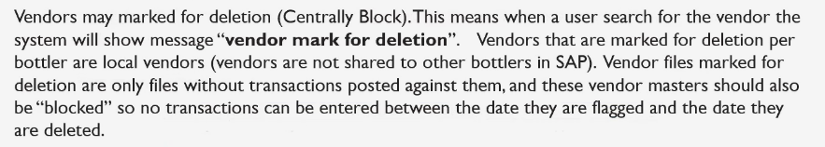

*If it is shared vendor we cannot centrally blocked and if it is not shared vendor, we can block centrally Types of forms required as a supporting document*

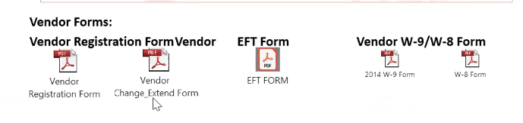

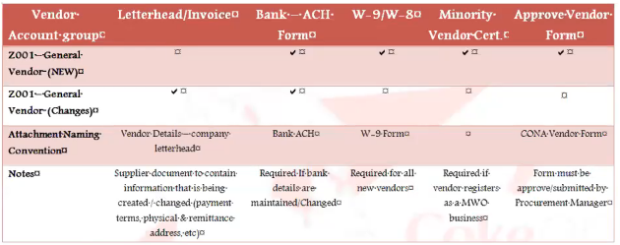

* *Details to be entered in vendor form*

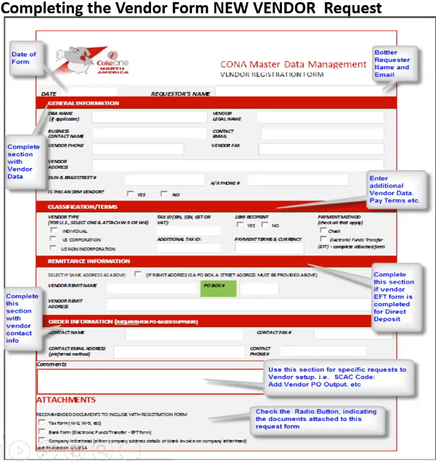

1. ***New Bank Validation Process***
   1. ***Bank details change request form***

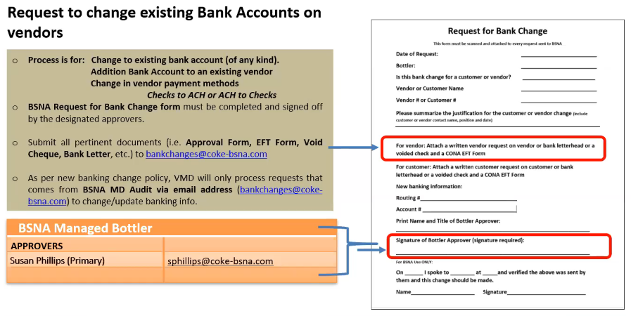

* 1. ***Flow chart of bank details updating***



* ***Creating raw material vendors***

***Will come from SAP direct create/update.(Most of the request for update)***

* *Standard required fields in Purchase org must be completed*

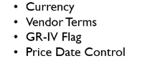

* *The below sample table will be included in request for mandatory fields*

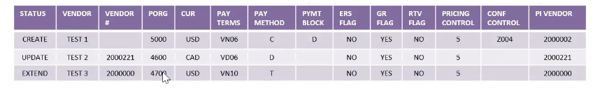

***Creating indirect PO vendors (Come directly from bottlers)***

* *Standard required fields in indirect PO based Vendors must be completed.*

*Delete for PO.*

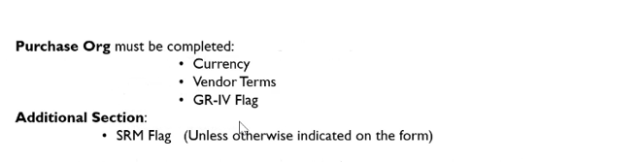

* *The below sample table will be included in request for mandatory fields*

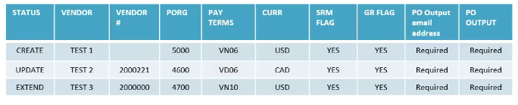

1. ***Steps to perform before processing Vendor Requests***

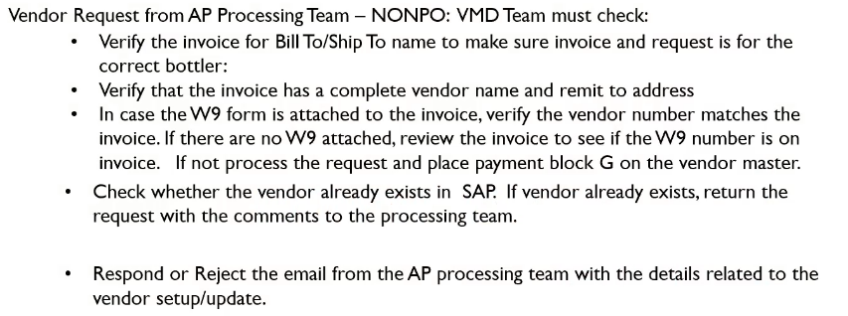

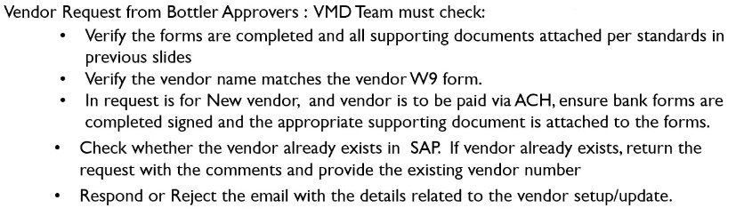

1. ***Default Payment terms***

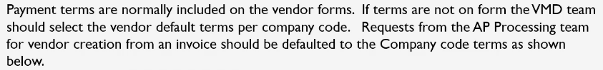

* *Payment methods which will be used for vendor creation and changes request*

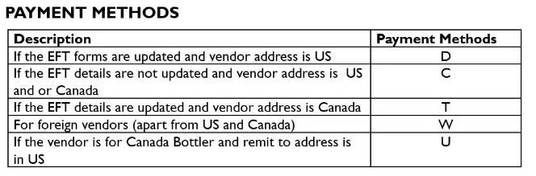

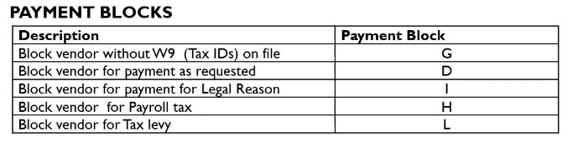

1. ***List of documents which needs to be processed in complete cycle of Vendor Master Data Management.***

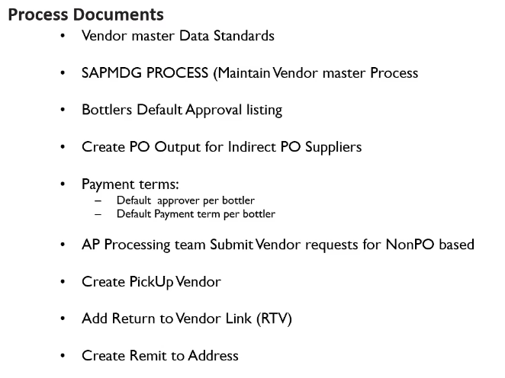

1. ***How to setup Vendor master.***

* *We will receive two attachments, which are required for vendor creation.*
* *Tax information letter*
* *New Vendor creation form*
* *Firstly, we need to check if the vendor is already created in the system through T.Code – XK03 by clicking on below highlighted field.*
* *If we found the vendor already in the system with same name, address , tax id we will reply back to sender and ask please confirm if we should extend.*

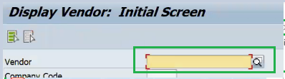

* *We need to search the Vendor through vendor form. For Eg: Legal name, Trade name, city, state.*

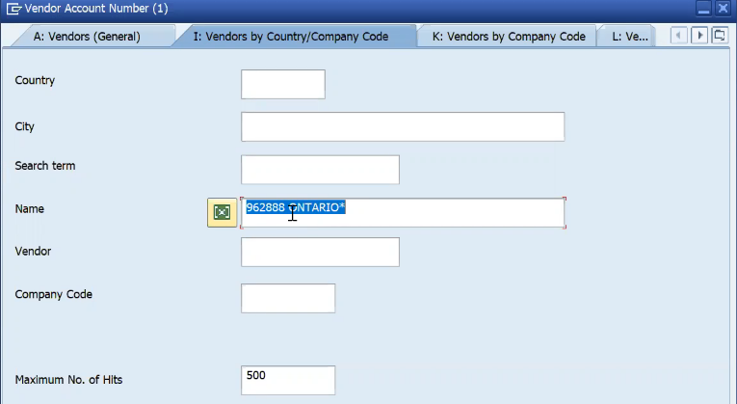

* *We will go to SAP MDG for creation of Vendor through below mentioned T-Code.*

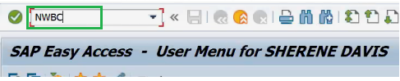

* *We need to click on Create ERP Vendor for creation. We will be working on below highlighted.*

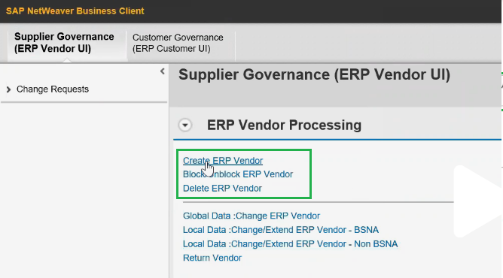

* *We will get the chance to view the vendor once again and will try to check if the Vendor is already created or not.*

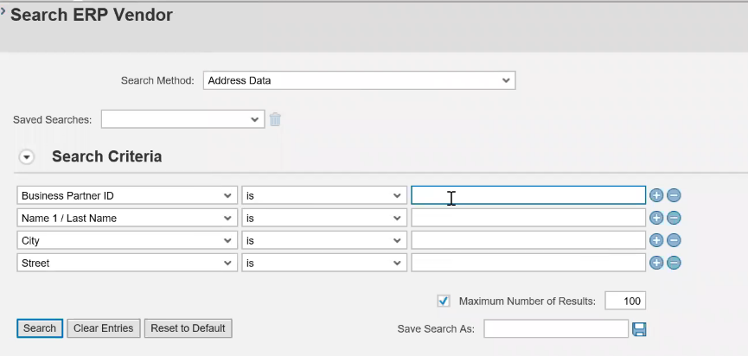

* *If there is no vendor found, we will click on Create ERP Vendor.*

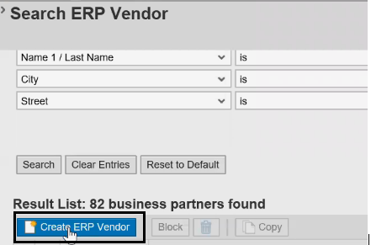

* *Data will be automatically populated in description. No other information will be updated in General Data.*

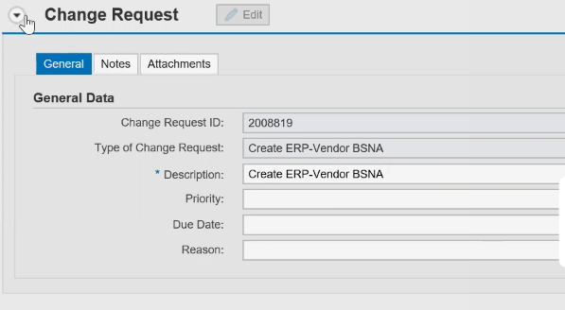

* *Always enter what action we are performing in the notes section.*

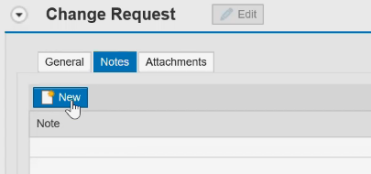

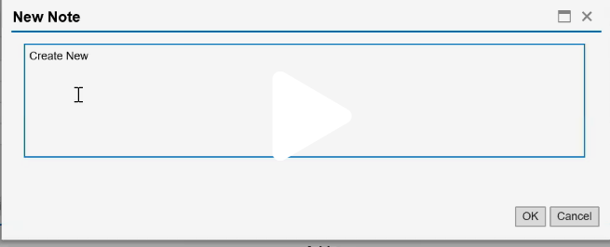

* ***ERP Vendor Details*** *- We will enter the below details under ERP Vendor Details. Please refer the below populated fields screenshot for details.*
* *DBA name – Name1 field. Excess detail will go in Name 4 field.*
* *Legal name – Name2 field*
* *Address details - Street details in Street*
* *Address details - House number in House. Extra detail will go in Street 2/ Street3*
* *Postal code – Will be mentioned after vendor address details*

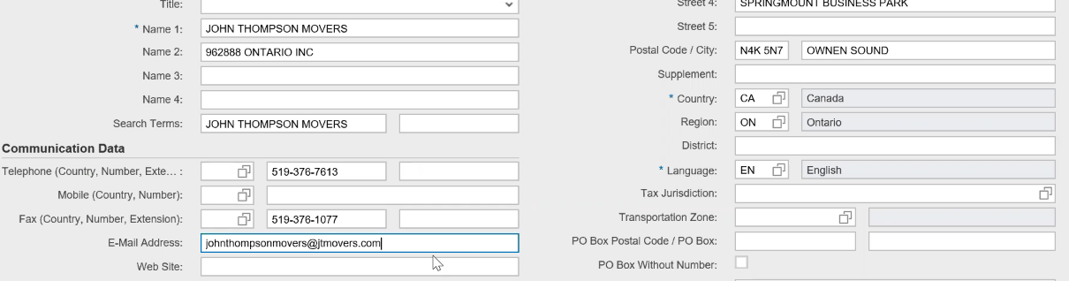

* *In case of different Remit address, we need to update P.O Box number.*

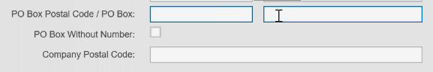

* *Tax Jurisdiction code will be auto populated through Vertex.*
* *Click on check for Tax code*

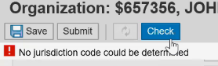

* *Trillium will update / correct the format of the address.*
* ***Vendor Additional Details*** *- We will check the SRM flag if it is mentioned in the form.*

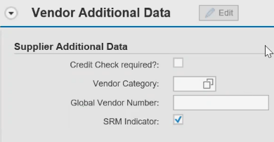

* ***Control Data*** *- In case of payroll vendor, we will update the group key. We do not fill the details for new vendors.*

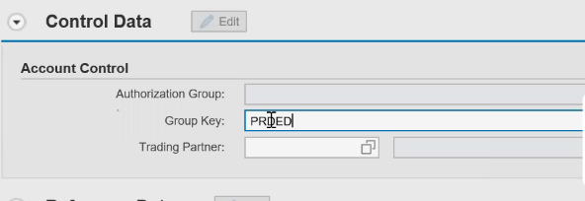

* ***Reference Data*** *- For Order freight vendor we enter the details under SCAC field. It will be used occasionally and with instructions.*

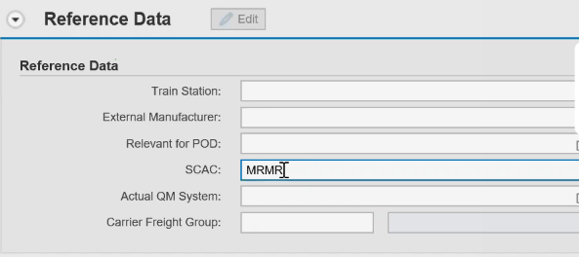

* ***Tax Number*** *- We need to enter W9 form and GST details by clicking on New.*

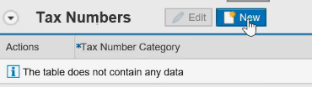

* 1. *Add details under Tax Number category by pressing F4.*

*For US vendors we use below category.*

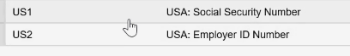

* 1. *For Canada vendors we use below category codes.*

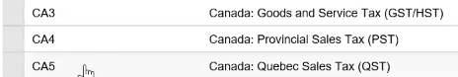

* *Enter the tax number as per the attached tax form in the below field.*



* ***Tax Information*** *- No information will be updated on for Canada Vendors.*

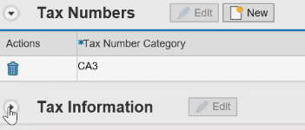

* ***Bank Details*** *- If we have bank details on the vendor form by clicking on New*
* *Bank Account number*
* *Bank Key*
* *Account holder will be auto updated.*



* *In case of cheque payments we do not update bank details.*
* ***Payment Transactions*** *– We need to check Payee in Document for permitted payee.*

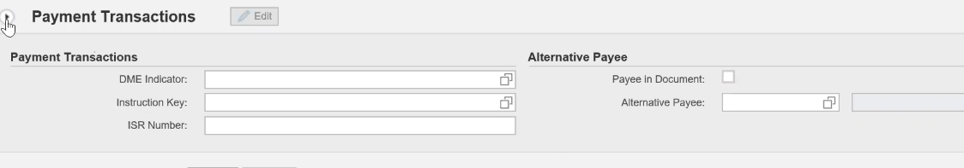

* ***Company Codes (Accounting Information)****– We will enter Reconciliation A/c default as mentioned below.*
* *Minority indicator will be updated as per details in form. For Canada we do not have minority indicator.*
* *Standard Sort key will be used - 009*

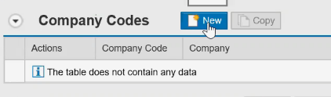

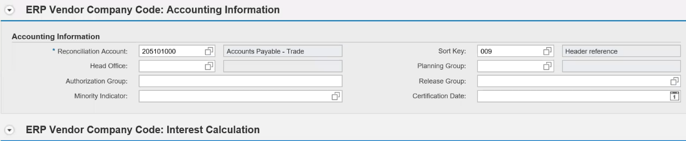

* ***Company Codes (Interest Calculation)*** *– We do not enter any details under this field.*
* ***Company Codes (Withholding Tax)*** *– No information for Canada Vendors.*
* ***Company Codes (Reference Data)*** *– We do not enter any details under this field.*
* ***Company Codes (Payment data)*** *– We update Terms of payment as below: Default otherwise as indicated on form.*

***Below are the examples:-***

* *VN60 – For 60 days’ payment*
* *VN45 – For 45 days’ payment*
* *VD10 – 2% 10 net 30.*
* *We will always check “Check double invoice”*

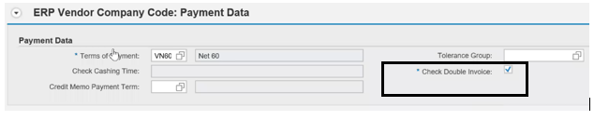

* ***Company Codes (Automatic Payment Transactions)*** *– We will update the payment methods by F4 or click on drop down and details mentioned in the form.*

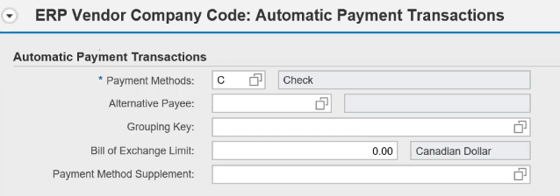

* ***Company Codes (Correspondence)*** *– We will update Clerk at Vendor if the vendor is Taulia.*
* ***Company Codes (Invoice Verification) & (Dunning Areas)*** *– No details need to be entered.*
* ***Company Codes (Extended Withholding Tax)*** *– No details to be entered for Canada Vendors and for US vendors we enter Withholding tax type and code.*
* ***Purchase Organization (Conditions)*** *– We click on new to enter the details.*
* *We will update Terms of payment same as payment data in Company code.*
* *We will update the order currency as the system take default as US dollar.*

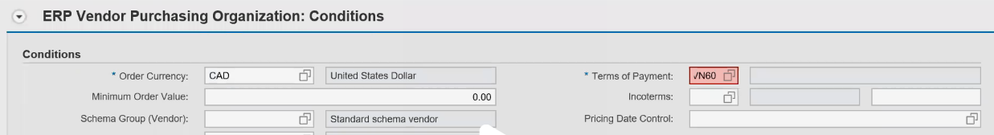

* ***Purchase Organization (Control Data)*** *– We will check the below fields for PO vendor.*

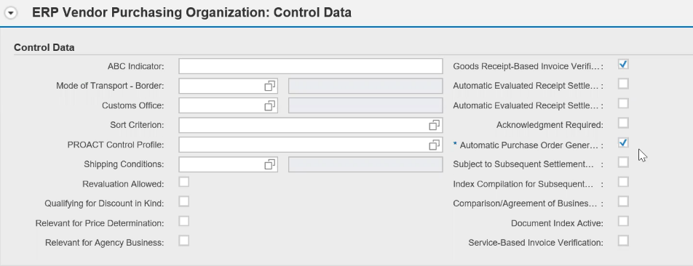

* ***No details need to be entered in below mentioned fields***

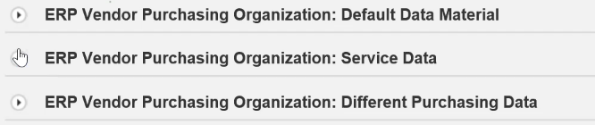

* ***Purchase Organization (Partner Functions)*** *– Details will be updated after the instructions received from SAP direct (BSNA).*

***Communication Information***

* ***Additional Purchasing Data*** *– No details to be entered under this section*

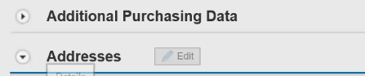

* ***Addresses*** *– We need to update Comm. Method under the Addresses tab.( This field is required for PO output, if vendor paid by ACH,)*



* ***We will check the details entered by clicking the below button.***

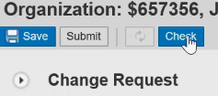

* ***If no errors are found, we will then attach the supporting documents received in email. We also need to attach the mail received in PDF format including email as well.***

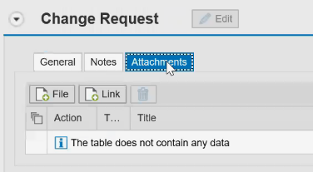

* ***Then click save and then submit. A doc number will be generated.***

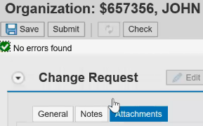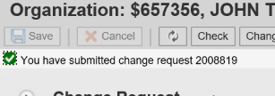

* *Click on workflow button to check the details as where the approval is pending.*

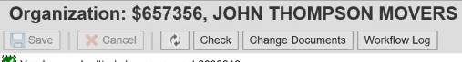

***Important things to adhere:***

1. ***No special characters in Name1 field***
2. ***Standard Sort key will be used - 009***
3. ***Standard Reconciliation A/c to be used as other wise instructed.***

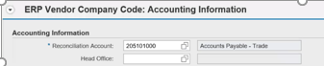

1. ***Refer below points for US Vendors:***

* *While creating the US vendors we often get the below vertex window for TJC code and we need to select the first option.*

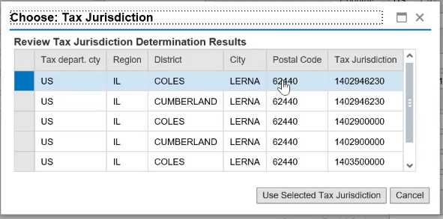

1. ***Tax code provided does not match with the available options we select 03 – Other Income option as default and then update the Recipient type***

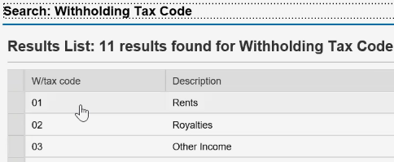



1. ***For PO based Vendor if there is no data for Terms of payment in Vendor form we need to send the form back to the BSNA team.***

***In case of NON PO based Vendor we will update the default terms of payment i.e. – VN 60***

***Note:*** *for vendor changes or update only. We need to check the SRM flag in the vendor data and create the PO output. If Vendor is extending, we need to double check the SRM flag right after.*

1. ***Extending vendor data to company code level.***

* *Firstly, we need to check if the vendor is already created in the system through T.Code – XK03 and SAPMDG to confirm the vendor and details*
* *We need to select the below highlighted link in SAPMDG.*

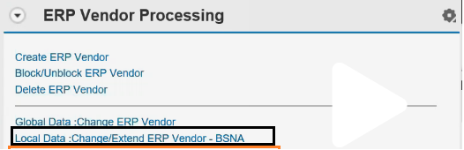

***Select the BSNA only***

* *We need to check if there are bank details updated in Vendor master we need to update the ACH and not updating “C” in payment methods unnecessary.*
* *Update the fields which needs to be updated as per the form provided.*
  1. ***Extending vendor data to Purchasing Org level.***
* *We need to update only below mentioned fields.*
* *Order Currency*
* *Terms of Payment*
* *Check the below two options as shown in screenshot*

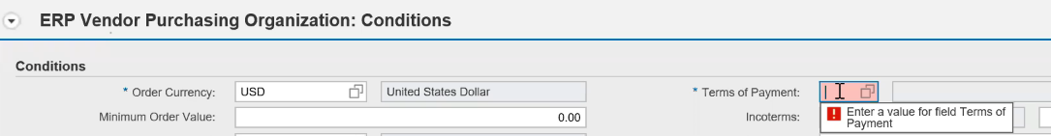

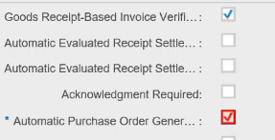

***Note: Always update the Description in Change Request.***

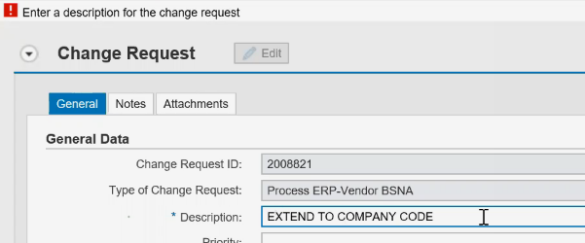

***Note -*** *To check the SRM flag first we need to update the details and get it validated/Approved.*

*Then go to global data and check the SRM flag for the extended Vendor and then create the PO output,*

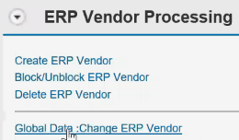

1. ***For Bank changes we need to refer the below main points:***

* *Signed ACH form and supporting documents from Bank will be required to update the Bank Details.*
* *Form details and Bank supporting details should match. For eg: Bank Account number and Routing Number.*
* *If Bank Key is incorrect then the system will show bank details incorrect in SAPMDG. We need to send the form again to the requester.*
* *We need to make sure the email address has “REMADV” as notes in email address field.*
* *In case of payment by check, we need to update Lockbox in below mentioned field (C/O).*
* *If there is no street address, we will update Lockbox in street address field.*

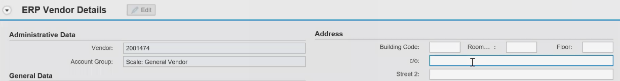

***Instructions for sending reminders****: -*

*Please note that when the status of case is pending with requestor then we need to send reminder email to requestor after every 48 Hrs.*